StorageClass
A StorageClass in Kubernetes defines how storage should be created automatically (dynamic provisioning) for PersistentVolumeClaims (PVCs).
A StorageClass in Kubernetes defines how PersistentVolumes (PV) should be created automatically.
It tells Kubernetes what type of storage you want and which provisioner should create it.
Why StorageClass is needed?
Without StorageClass:
- Admin creates PV manually
- PVC must match PV manually
- Slow and not scalable
With StorageClass:
- PV is created automatically (dynamic provisioning)
- No manual PV creation required
- Faster and scalable
1.Setup an NFS Server
#sudo yum install nfs-utils -y
#sudo mkdir -p /nfs-volume
#sudo chmod -R 777 /nfs-volume
#vi /etc/exports
/nfs-volume *(rw,sync,no_root_squash)
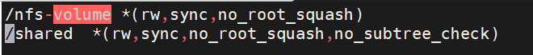

#systemctl enable --now nfs-server
#sudo exportfs -rav
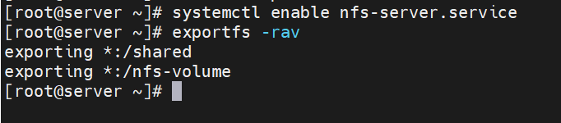
install nfs on master/worker node
#apt install nfs-kernel-server -y
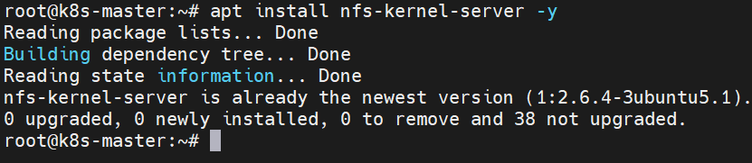
2.Installing the NFS provisioner
#curl -skSL https://raw.githubusercontent.com/kubernetes-csi/csi-driver-nfs/v4.5.0/deploy/install-driver.sh | bash -s v4.5.0 --
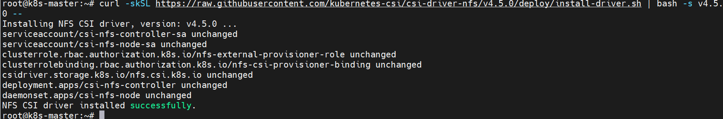
Create StorageClass for NFS
Vi storageclass.yaml
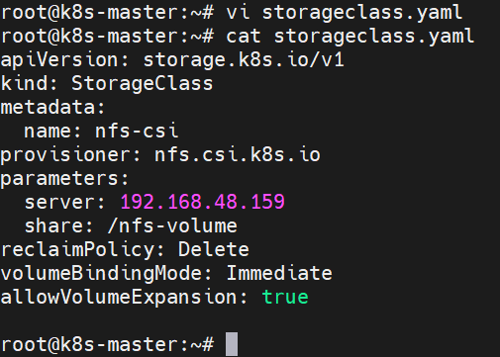

kubectl apply -f storageclss.yaml
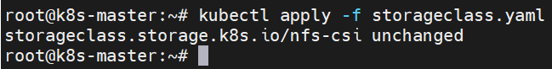
Create a PersistentVolumeClaim (PVC)
Vi storageclass-pvc.yaml
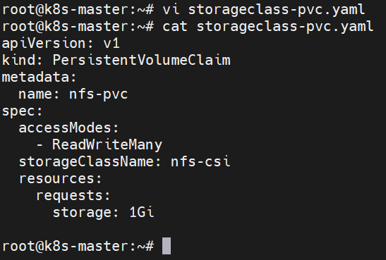
Kubectl create -f storageclss-pvc.yaml
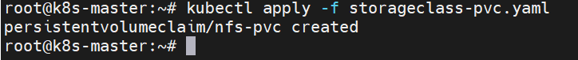
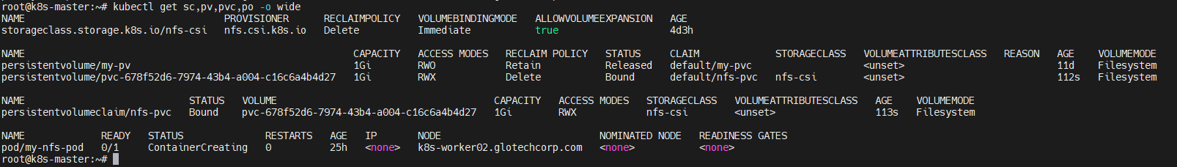
Create a Pod to Use the PVC
Vi storageclass-pvc-pod.yaml
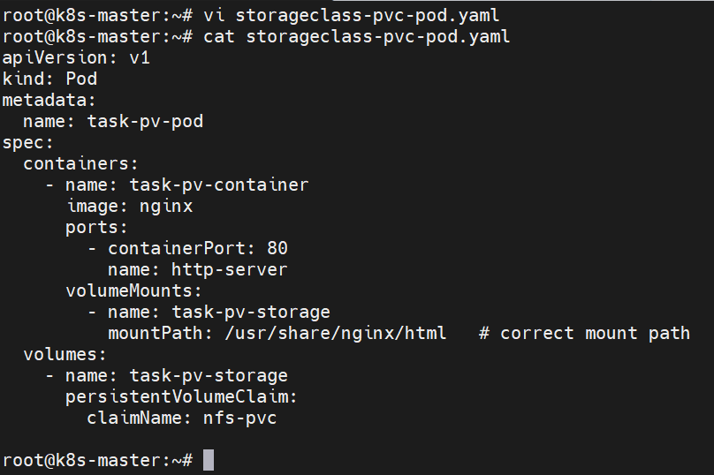

Kubectl create -f storageclss-pvc-pod.yaml
